|  |  |  |  |  |  |  |  |  |
| --- | --- | --- | --- | --- | --- | --- | --- | --- |
| **SCHOOLOFCOMPUTER SCIENCE AND ARTIFICIAL INTELLIGENCE** | | | | | **DEPARTMENTOFCOMPUTER SCIENCE ENGINEERING** | | | |
| **ProgramName:**B. Tech | | | | **AssignmentType: Lab** | | | **AcademicYear:**2025-2026 | |
| **CourseCoordinatorName** | | | | Venkataramana Veeramsetty | | | | |
| **Instructor(s)Name** | | | | 1. Dr. Mohammed Ali Shaik  2. Dr. T Sampath Kumar  3. Mr. S Naresh Kumar  4. Dr. V. Rajesh  5. Dr. Brij Kishore  6. Dr Pramoda Patro  7. Dr. Venkataramana  8. Dr. Ravi Chander  9. Dr. Jagjeeth Singh | | | | |
| **CourseCode** | | | 24CS002PC215 | **CourseTitle** | | AI Assisted Coding | | |
| **Year/Sem** | | | II/I | **Regulation** | | R24 | | |
| **DateandDay**  **of Assignment** | | | 06-08-2025 | **Time(s)** | |  | | |
| **Duration** | | | 2 Hours | **Applicableto**  **Batches** | |  | | |
| **AssignmentNumber:6.5**(Presentassignmentnumber)/**24**(Totalnumberofassignments) | | | | | | | | |
|  | | | | | | | | |
|  | **Q.No.** | **Question** | | | | | | ***ExpectedTime***  ***to complete*** |  |
|  | 1 | **Lab 6: AI-Based Code Completion: Working with suggestions for classes, loops, conditionals**  Lab Assignment 1: Intelligent Code Completion for Object-Oriented Programming  **Objective:**To explore AI-powered code assistants for writing Python classes, constructors, and methods through intelligent suggestions.  Suppose that you are hired as an intern at a tech company that develops inventory management systems. Your manager asks you to create a **Product** class and a **Warehouse** class with some basic methods. You have decided to use AI-powered code suggestions to help speed up development and reduce syntax errors.  Tasks to be completed are as below  **1. Setup AI Coding Tool:**   * Install and configure GitHub Copilot or Kite with VS Code or JetBrains IDE. * Enable real-time code suggestions.   **2. Class Design Using AI Assistance:**   * Begin defining a Product class with attributes: name, price, quantity. * Use the AI suggestion feature to automatically complete the __init__() method. * Add a method calculate_value() to return price * quantity.   **3. Create Another Class:**   * Define a Warehouse class with a list of Product objects. * Use code completion to help implement**:**   + A method to add a product.   + A method to display the most valuable product.   **4. Reflection:**   * Identify how much of the code was completed by AI and what manual edits were needed. * Comment on the relevance and accuracy of AI suggestions.   **Requirements:**   * VS Code with Github Copilotor Cursor API and/or Google Colab with Gemini   **Deliverables:**   * Python script with both classes and comments on AI-generated suggestions. * Short report (1 page) summarizing your experience with AI code completion.   . | | | | | | 15.08.2025 EOD |  |

**2. Class Design Using AI Assistance:**

* Begin defining a Product class with attributes: name, price, quantity.
* Use the AI suggestion feature to automatically complete the __init__() method.
* Add a method calculate_value() to return price * quantity.

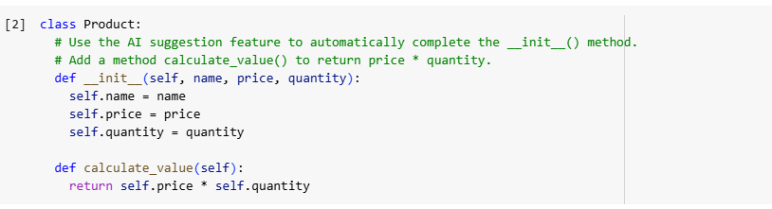

**. Create Another Class:**

* Define a Warehouse class with a list of Product objects.
* Use code completion to help implement**:**
  + A method to add a product.
  + A method to display the most valuable product.

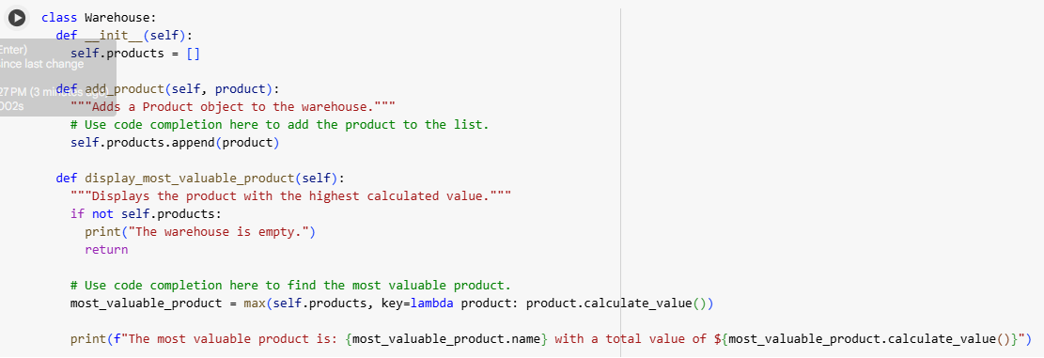

**4. Reflection:**

* Identify how much of the code was completed by AI and what manual edits were needed.
* Comment on the relevance and accuracy of AI suggestions.

**Requirements:**

* VS Code with Github Copilotor Cursor API and/or Google Colab with Gemini

**Deliverables:**

* Python script with both classes and comments on AI-generated suggestions.
* Short report (1 page) summarizing your experience with AI code completion.

